**Welcome Back Turtle Assignment:**

1. 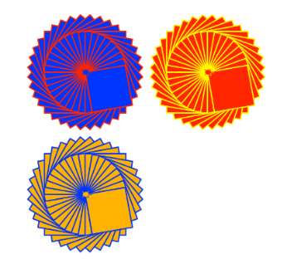Create a Python Turtle program to do the following:
2. Draw an interesting shape using multiple basic shapes   
   and pen colors.
3. Use the **goto(x,y)** function to move the starting point for the shape   
   to a different location on the output window.
4. Use a **counted loop** to draw multiple copies of your shape at different   
   positions on the output window.
5. Use the **input()** function to ask for a number of times to repeat the shape. Use this number to control the repeat of the counted loop.
6. Extension. Check the repeat number input to make sure it is a valid number and that it is between the range of 1 to 6 repeats.
7. Use print screen to copy and paste an image of your program output below.

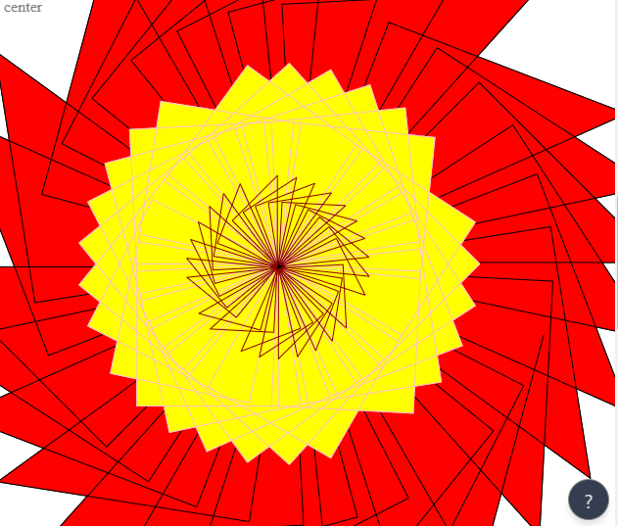

1. Provide a listing of your Python program below.

import turtle

myPen = turtle.Turtle()

myPen.color("blue")

j = 1

while j == 1:

amount = int(input("How many times would you like the shape to repeat: "))

if amount <= 30:

j = 2

else:

print("please input a number under 30.")

continue

import turtle

myPen = turtle.Turtle()

myPen.speed(100)

myPen.color("black")

myPen.fillcolor("red")

myPen.begin_fill()

i = 0

while i <= amount:

myPen.forward(360)

myPen.left(135)

myPen.forward(260)

myPen.left(90)

myPen.forward(280)

myPen.left(3)

i = i + 1

myPen.end_fill()

myPen.color("pink")

myPen.fillcolor("yellow")

myPen.begin_fill()

i = 0

while i <= amount:

myPen.forward(145)

myPen.left(90)

myPen.forward(145)

myPen.left(90)

myPen.forward(145)

myPen.left(90)

myPen.forward(145)

myPen.left(3)

i = i + 1

myPen.end_fill()

myPen.color("dark red")

myPen.fillcolor("black")

myPen.begin_fill()

i = 0

while i <= amount:

myPen.forward(90)

myPen.left(135)

myPen.forward(65)

myPen.left(90)

myPen.forward(70)

myPen.left(3)

i = i + 1